Steps for Importing data into MongoDB Database.

1. After starting the Mongo server & Mongo Shell, open another command prompt window.
2. Next, we need to create a database using “use” command in mongo shell. Below screenshot shows the creation of a database named “Transit Application database”.

Format of command:

>use <DatabaseName>

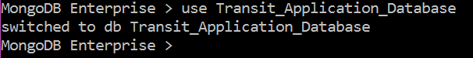

1. Now, to import each of the collection into “Transit Application_Database” we can use “mongoimport” Tool. “mongoimport” Tool can be used to import contents from json, csv, or TSV files.

For our project, we created json files for each of the collection and then imported them into MongoDB using above mentioned command.

Below are the links to each of the json files we created:

**Note:** To open json file in readable format, copy the link to your PC and open it using notepad.



Below screenshots shows the import of each of the collection into MongoDB:

**Note:**  **1. “mongoimport” tool works on command prompt and not on mongo shell.**

**2. Make sure, while writing the mongoimport command you are in the same directory where the json file is stored.**

Format of the command: -

>mongoimport --db <database name> --collection <colection name> --type json <JSON File name>

1. To import collection Car:

>mongoimport --db Transit_Application_Database --collection car --type json Car.json



1. To import collection Driver:

>mongoimport --db Transit_Application_Database --collection driver --type json Driver.json



1. To import collection Location:

>mongoimport --db Transit_Application_Database --collection location --type json Location.json



1. To import collection Customer:

>mongoimport --db Transit_Application_Database --collection customer --type json customer.json



1. To import collection Trip:

>mongoimport --db Transit_Application_Database --collection trip --type json trip.json



1. To import collection Route:

>mongoimport --db Transit_Application_Database --collection route --type json Route.json



1. To check that all the collections are added successfully into the database, open MongoDB shell (make sure you are in “Transit_Application_Database” (step:2)). Type command “show collections” and press enter.

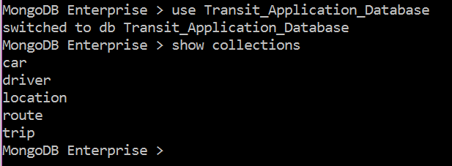

1. To add timestamp key to each of the document of “Trip” & “Route” collection use below commands in Mongo Shell:
2. For trip entity.

>db.trip.updateMany({},{$set:{"TIME STAMP": new Date()}},false,true)



1. For route entity.

>db.route.updateMany({},{$set:{"TIME STAMP": new Date()}},false,true)



1. To check out a few of the documents in the collection, use below command

Format of the command: -db.<collection_name>.find().pretty()

> db.location.find().pretty()